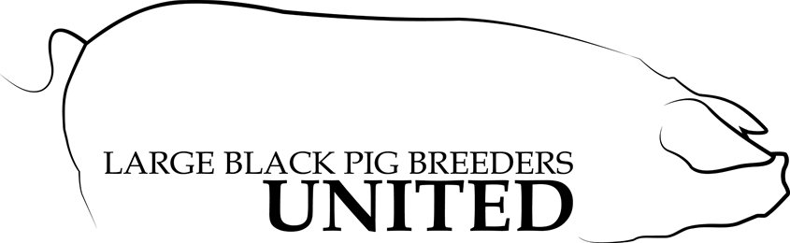
Large Black Pig Breeders United
16383 County Road 75
Kenton, Ohio 43326
567-674-2542

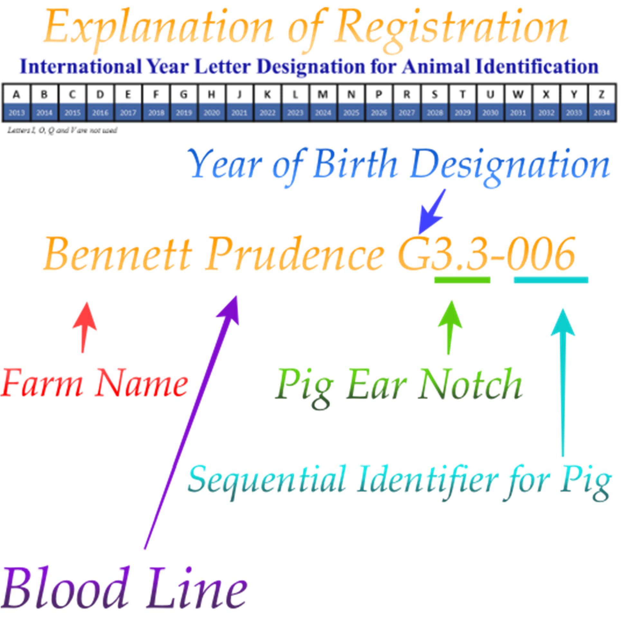

Felicia Krock ↔ 16383 County Road 75 ↔ Kenton Ohio 43326 567-674-2542 ↔ swineherd@lbpbu.com

