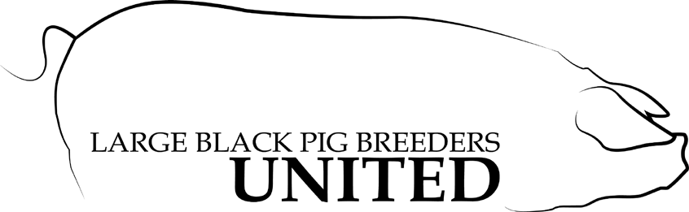

Trial Mating
Large Black Pig Breeders United
16383 County Road 75
Kenton, Ohio 43326
567-674-2542

Name of Farm:

Member Number

Name of Sow

Name of Boar
OR
Name of Grand Sow #1

Name of Grand Boar #1

Name of Grand Sow #2

Name of Grand Boar #2

Return to
Felicia Krock ↔ 16383 County Road 75 ↔ Kenton Ohio 43326 567-674-2542 ↔ swineherd@lbpbu.com

